# Documentation Test-Sinbad

## UseCase

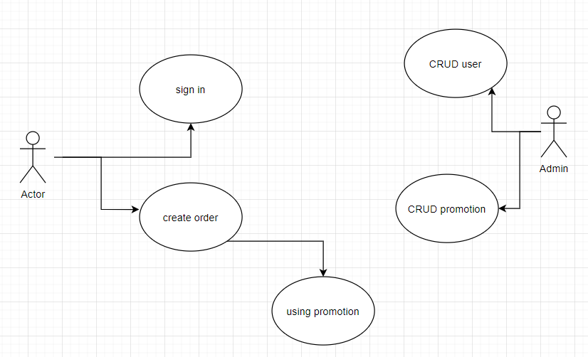

## Entity Relation Diagram

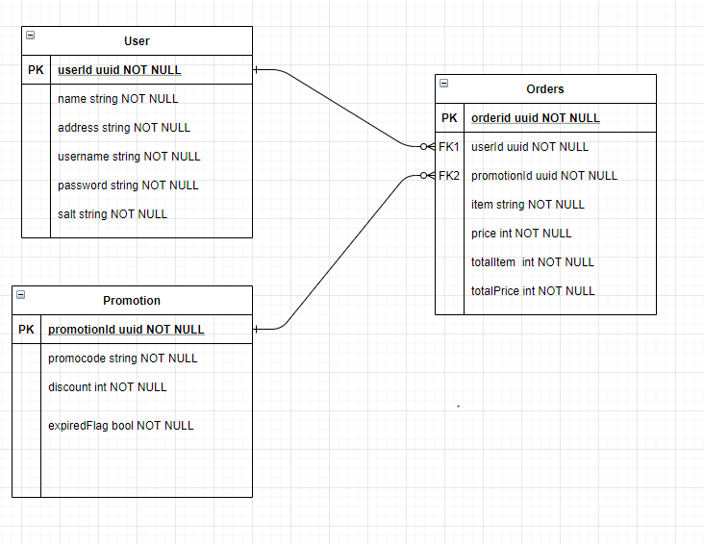

## Endpoints

Please go to here: [Excel EndPoints](EndPoint%20Documentation.xlsx)